**Details related to add new status switch in the dataset and other places.**

The status_switch has added to the database colomn and the data type is Boolean.

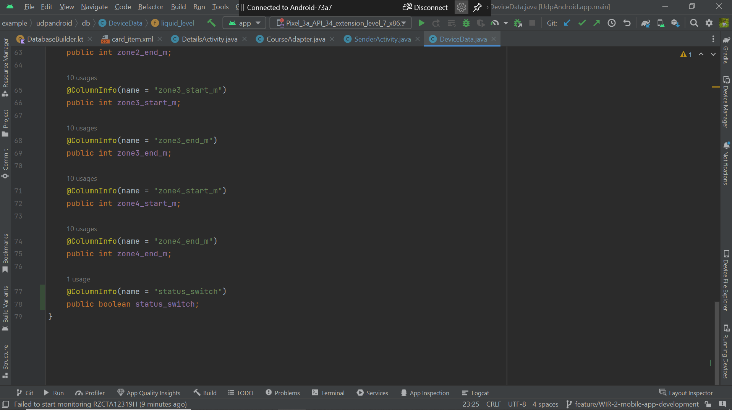

The Status_switch has made as true for now, later will update with the data received from the hardware device.

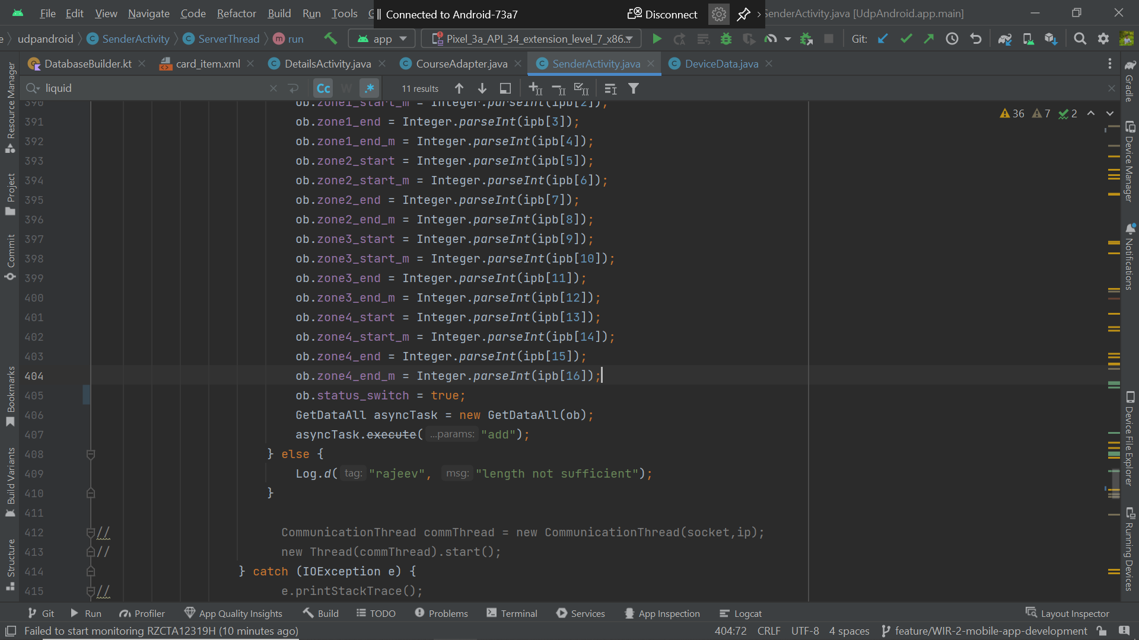

Device_data.java

package com.example.udpandroid.db;  
  
import androidx.room.ColumnInfo;  
import androidx.room.Entity;  
import androidx.room.PrimaryKey;  
  
import java.io.Serializable;  
  
@Entity  
public class DeviceData implements Serializable {  
 @PrimaryKey(autoGenerate = true)  
 public int uid;  
  
 @ColumnInfo(name = "unique_id")  
 public String unique_id;  
  
 @ColumnInfo(name = "device_name")  
 public String device_name="";  
  
 @ColumnInfo(name = "ip")  
 public String ip;  
  
 @ColumnInfo(name = "liquid_level")  
 public int liquid_level;  
  
 @ColumnInfo(name = "intensity_level")  
 public int intensity_level;  
  
 @ColumnInfo(name = "zone1_start")  
 public int zone1_start;  
  
 @ColumnInfo(name = "zone1_end")  
 public int zone1_end;  
  
 @ColumnInfo(name = "zone2_start")  
 public int zone2_start;  
  
 @ColumnInfo(name = "zone2_end")  
 public int zone2_end;  
  
 @ColumnInfo(name = "zone3_start")  
 public int zone3_start;  
  
 @ColumnInfo(name = "zone3_end")  
 public int zone3_end;  
  
 @ColumnInfo(name = "zone4_start")  
 public int zone4_start;  
  
 @ColumnInfo(name = "zone4_end")  
 public int zone4_end;  
  
 @ColumnInfo(name = "zone1_start_m")  
 public int zone1_start_m;  
  
 @ColumnInfo(name = "zone1_end_m")  
 public int zone1_end_m;  
  
 @ColumnInfo(name = "zone2_start_m")  
 public int zone2_start_m;  
  
 @ColumnInfo(name = "zone2_end_m")  
 public int zone2_end_m;  
  
 @ColumnInfo(name = "zone3_start_m")  
 public int zone3_start_m;  
  
 @ColumnInfo(name = "zone3_end_m")  
 public int zone3_end_m;  
  
 @ColumnInfo(name = "zone4_start_m")  
 public int zone4_start_m;  
  
 @ColumnInfo(name = "zone4_end_m")  
 public int zone4_end_m;  
  
 @ColumnInfo(name = "status_switch")  
 public boolean status_switch;  
}

Database_builder.kt

package com.example.udpandroid.db  
  
import android.content.Context  
import androidx.room.Room  
  
object DatabaseBuilder {  
 private var INSTANCE: AppDatabase? = null  
 fun getInstance(context: Context): AppDatabase {  
 if (INSTANCE == null) {  
 *synchronized*(AppDatabase::class) **{** INSTANCE = buildRoomDB(context)  
 **}** }  
 return INSTANCE!!  
 }  
  
 private fun buildRoomDB(context: Context) =  
 Room.databaseBuilder(  
 context.*applicationContext*,  
 AppDatabase::class.*java*,  
 "devices_data"  
 ).fallbackToDestructiveMigration()  
 .addMigrations(AppDatabase.*MIGRATION_2_3*)  
 .build()  
  
  
  
}

AppDatabase.java

package com.example.udpandroid.db;  
  
import androidx.room.Database;  
import androidx.room.RoomDatabase;  
import androidx.room.migration.Migration;  
import androidx.sqlite.db.SupportSQLiteDatabase;  
  
@Database(entities = {DeviceData.class,PropertyData.class,UserData.class}, version = 3)  
  
public abstract class AppDatabase extends RoomDatabase {  
 public abstract DeviceDao deviceDao();  
 public abstract PropertyDaoDao propertyDao();  
 public abstract UserDaoDao userDaoDao();  
 static final Migration *MIGRATION_2_3* = new Migration(2, 3) {  
 @Override  
 public void migrate(SupportSQLiteDatabase database) {  
 // Add a new column 'status_switch'  
 database.execSQL("ALTER TABLE DeviceData ADD COLUMN status_switch BOOLEAN NOT NULL DEFAULT 0");  
  
 // If you want to set a default value for existing rows, you might need to do an UPDATE  
 // For example, if you want to set 'status_switch' to true for all existing rows:  
 // database.execSQL("UPDATE DeviceData SET status_switch = 1 WHERE 1");  
 }  
 };  
  
}